**A Simulation System and Speed Guidance Algorithms for Intersection Traffic Control Using Connected Vehicle Technology**

**Abstract:** In the connected vehicle environment, it is possible to obtain real-time vehicle-state data through vehicle-to-infrastructure communication, and significantly increase the prediction accuracy of urban traffic conditions. This study uses the C++/Qt programming language and framework to build a simulation platform. A two-way six-lane intersection was set up on the simulation platform. In addition, two speed guidance algorithms basing on optimizing the travel time of a single vehicle or multi vehicles respectively are proposed. The goal of optimization is to minimize the travel time, with the common indicators such as average delay of vehicles, average number of stops, and average stop time chosen as indexes of traffic efficiency. The simulation results show that when the traffic flow is not saturated, compared with the case of no speed guidance, single-vehicle speed guidance can improve the traffic efficiency by 20%, whereas multi-vehicle speed guidance can improve the traffic efficiency by 50%. When the traffic flow is saturated, the speed guidance algorithms have performances that are more outstanding. With the increase of penetration rate, the effect of speed guidance gradually enhances, with the most obvious gains obtained when the penetration rate increases from 10% to 40%. Thus, this study has shown that speed guidance in the connected vehicle environment can significantly improve the traffic efficiency of intersections, and compared with the single-vehicle speed guidance strategy, the multi-vehicle speed guidance strategy is more effective.

**Keywords:** connected vehicle; intersection traffic control; simulation system; speed guidance

INTRODUCTION

The concept of cooperative driving was first introduced in the early 1990s. A cooperative driving vehicle can control its velocity and trajectory to optimize objectives of traffic efficiency, e.g. average delay and average stop time. In 2006, Li et al. proposed the concept of “safety driving patterns” to obtain the allowable movement schedules of all vehicles which entered the intersection via traffic lights and Vehicle-to-Infrastructure (V2I) communication [1] [2]. The connected vehicle technology has become one of the cutting-edge technologies in the field of intelligent transportation today. It is an effective way to improve traffic efficiency, increase road safety, and reduce traffic pollution [3]. The connected-vehicle system has obvious positive effects on improving the efficiency of traffic networks. When vehicles are connected to each other, the drivers’ reaction time can be shortened, and the headway between vehicles can also be shortened, thus leading to higher road occupancy and higher road capacity [4]. Under the connected-vehicle environment, the full-time acquisition of vehicle state data can effectively improve the prediction accuracy of urban traffic conditions [5]. Using real-time V2I communication instead of traditional detectors can improve the timely response ability of the road traffic signal controller [6]. In addition, monitoring the states of platoons can make the control and coordination of traffic signals more accurate [6].

Nowadays, researchers have conducted several studies on speed guidance under the connected-vehicle environment. Nekoui explored the issue of road traffic safety by mathematical models and field experiments. They revealed that introducing speed guidance under the connected-vehicle environment could effectively relieve the problems of vehicle emergency avoidance and collision avoidance under different conditions [7]. Malakorn and Park examined a cooperative transportation system, which allowed vehicles to accept trajectory instructions from an intelligent traffic signal using the two-phase signal-timing plan, and found that it was highly beneficial in terms of both mobility and fuel consumption [8]. Abu-Lebdeh analyzed the feasibility of dynamic speed control in his paper, and discussed its potential benefits in the field of traffic control [9].

Yang et al. studied main rural roads [10]. They proposed a speed guidance strategy considering factors such as the location of vehicles, the status of signal controls, the acceleration and deceleration time of vehicles, drivers’ acceptance, and etc. They further used the VISSIM software, a microscopic simulator, to simulate the connected-vehicle environment in order to validate their speed guidance strategy. Chen et al. used roadside variable message signs as display terminals for speed guidance [11]. Considering the locations of roadside speed guidance equipment and signal timing, they put forward a strategy which combines dynamic speed guidance and dynamic signal control to optimize the arterial coordinated signal control system. He used the real-time traffic data from V2V (Vehicle-to-Vehicle) and V2I communication to establish a platoon recognition algorithm basing on headways [12]. In addition, an optimized signal-control model named PAMSCOD (Platoon-based arterial multi-modal signal control with online data) was proposed using mixed integer linear programming for the coordination between several arterial intersections [12]. Lee and Park proposed a cooperative vehicle control algorithm which minimized the total length of overlapped trajectories to avoid potential collisions in the intersection [13]. Jackline and Andreas proposed a close-form solution in a centralized fashion for cooperative-driving vehicles to merge at expressway on-ramps [14].

Given the limited deployment of Cooperative Vehicle Infrastructure Systems (CVIS), simulation study is a very important research method. Currently, mature commercial traffic simulation software such as VISSIM, Paramics, and TransModeler are widely used [15]. However, they cannot realize V2V or V2I communication, neither can they realize real-time intervention of the running status of vehicles.

The smart CVIS of China is named as i-VICS (Intelligent Vehicle-Infrastructure Cooperation Systems), which is the research result of related studies in the recent ten years [16-18]. Basing on the technical characteristics of i-VICS, this study designed an intersection simulation system in the CVIS environment which realizes V2V and V2I communication and real-time intervention of the running status of vehicles. In addition, two speed guidance algorithms were proposed and tested in the self-developed simulation system.

The remaining of this paper is organized as follows. Section 2 describes the methodologies including the vehicle dynamics description and speed-guidance algorithms. Section 3 introduces the simulation system we designed in this research. A simulation-based case study and the corresponding results are presented in Section 4. Finally, concluding remarks are presented in Section 5.

METHODOLOGY

In this section, we use mathematical language to model the intersection traffic control problem in the connected vehicle environment. Firstly, the vehicle dynamics model is provided. Then, the way vehicles move without speed guidance is described. Next, the two speed-guidance algorithms we designed, named the single-vehicle speed guidance algorithm and the multi-vehicle cooperative speed guidance algorithm, are introduced. Finally yet importantly, the constraints of the system are listed.

1. **Vehicle Dynamics Description and Assumption**
2. Definition of variables

For the convenience of expression, the main variables to be used are defined in Table 1.

Table 1 The definition of main variables

|  |  |
| --- | --- |
| Variable | Definition |
|  | System state, including the traffic condition and the controlled variables |
|  | Traffic condition, including the states of all the vehicles in the current system |
|  | Functional parameters |
|  | Controlled variables, including the guided speed and the information of the traffic light (Boolean variable, with 0 representing red light, and 1 representing green light) |
|  | Vector of the vehicle state, including three dimensions of current speed, location, and waiting time |
|  | Acceleration (assumed constant, positive when speeding up, and negative when slowing down) |
|  | Distance from the current position to the stop-line |
|  | Travel time (the time interval between the current moment and the moment leaving the stop-line) |
|  | Guided speed |
|  | Current speed |
|  | Total waiting time in the waiting area |
|  | Discount factor |
|  | Real value of the optimization function |
|  | One-step cost function |

From the above definition, the system state can be expressed as , with  and  defined as:



In the above equations, *N* is the current total number of vehicles in the system.

The vehicle state (vector)  can be expressed as:



Whereas the controlled variable  can be denoted as:



with 

The simple dynamic equation of a vehicle passing the stop-line can be expressed as:



For a constant acceleration , the above equation can be written as:



Thus, we obtain



For a vehicle which is in the stop state, the travel time  can be calculated through the following equation:



With .

1. Basic assumptions

In order to simplify the research process, we made the following basic assumptions in this research:

1. The studied region is a single intersection, i.e. the influence of other intersections does not need to be considered.
2. The length of guiding region is 100m away from the stopping line in every direction.
3. The signal at the intersection is controlled using fixed-cycle strategies.
4. The vehicles have changed lanes before entering the controlled region, i.e. the vehicles will not change lanes in the controlled region.
5. The vehicles with on-board equipment will follow the speed-guidance strategies.
6. When the vehicles pass the stop-line and enter the intersection, they will return to the state of autonomous driving.
7. **Driving Behavior without speed guidance**

When there is no speed guidance, a vehicle’s straight driving behavior can be classified into free driving and car following. We define 150 meters as the distance of interaction between vehicles, the same as that of the VISSIM simulation system. Thus, the two driving behaviors are as follows:

1. When the distance to the front vehicle is equal to or greater than 150 meters, the driver chooses the free driving strategy, and tries to reach the maximum speed (defined as 90% of the speed limit of the road) as soon as possible.
2. When the distance to the front vehicle is less than 150 meters, the driver chooses the car following strategy. The commonly used driving psycho-physical model—Wiedemann model [19] is adopted in this study.



In the above equation,  represents the expected minimum safe-following distance. According to the regulations on safe distance in *Regulation on the Implementation of the Road Traffic Safety Law of the People’s Republic of China* [20], the linear correlation model of the minimum safe following distance and the speed of the front vehicle is used:



In the above equation,  is a linear coefficient,  is the minimum headway when stopped. For instance, when the speed of the front vehicle is 50 km/h, the minimum safe-following distance of the vehicle behind is 40 m.

1. **Speed-guidance algorithms**
2. The single-vehicle speed guidance algorithm

Currently, in the driving process, most vehicles cannot acquire the signal control information of the front intersection in real-time, neither can the drivers judge in advance whether they can pass the stop-line in the current signal cycle or not. Therefore, the drivers can only rely on experience and driving habits to decide the speed of the vehicle. With the emergence of connected-vehicle technology, vehicles can acquire the real-time information of traffic conditions and signal information, therefore it is possible to adjust vehicle speed through speed guidance and to increase the traffic efficiency. If we chose a vehicle as the object of speed guidance and set its minimum travel time as the optimization objective, the speed-guidance process can be described as:

1. When the vehicle enters the guiding region, the signal is green, and there is no vehicle in the queue.

At this time, our goal is to make the vehicle pass the stop-line as soon as possible before the green light ends. Thus, the optimize function is:

 and 

 is the moment that the green light was turned on, and  is the duration of the green light.

If there is no feasible solution (i.e.), it means that this vehicle cannot pass the stop-line through speed guidance and have to enter the queue, which can be classified into the next situation.

1. When the vehicle enters the guided region, the signal is red; or the signal is green, but the queue has not dissipated.

At this time, our goal is to make the vehicle arrive at the intersection when the queue has just dissipated. Thus, the optimize function is:

 and 

 is the loss of the first vehicle’s boot time,  is the current number of vehicles in the queue, and is the saturation flow rate of this lane.

By solving the above objective function, we can obtain the speed control strategy to be taken right now, that is, the acceleration that should be accepted by the current vehicle.

1. The multi-vehicle cooperative speed guidance algorithm

According to the above description, the time that each vehicle needs to pass the stop-line can be expressed by mathematical functions. Basing on this, we can build the optimization function with the objective of minimizing the total time needed by all vehicles to pass the stop-line.

First of all, the one-step cost function  is defined as follows:



Its physical meaning is the difference of total time that all vehicles needed to pass the stop-line between the two calculation moments.

Thereby, we can define the cost function  as:



In the above equation, is the discount factor, which can help to obtain the best effect as much as possible at the first step of optimization.

The optimization function of this optimization problem is:



Similarly, we can obtain the control strategy to be taken right now, that is, the acceleration to be accepted by the current guided vehicle.

1. **Constraints**

The constraints of the system are listed as follows:

1. The time constraint of the ‘head vehicle’ (the first vehicle in the queue) to pass the stop-line. After the green signal lights up, the time of the first vehicle behind the stop-line to pass the stop-line should be equal to or larger than the time that the green signal lights up:



1. The time constraint between the stop state and the booting process. After the green signal lights up, if the first vehicle behind the stop-line is in the stop state, the time it passes the stop-line should be equal to or larger than the sum of the time that the green light is turned on () and the loss of the first car’s boot time ():



1. The time constraint for two consecutive vehicles to pass the stop-line. The time for the latter vehicle to pass the stop-line should be equal to or larger than the sum of the time that the vehicle before it passes the stop-line and the minimum headway ():



1. The constraint of optimized speed. The optimized speed calculated by the model should lie between the low and high thresholds of speed. If the optimized speed is not in this range, it means the vehicle has to stop and wait:



1. The constraint of the number of vehicles passing the stop-line. The number of vehicles passing the stop-line in one signal cycle should be smaller than or equal to the volume under saturated state:



In the above equation,  is the number of lanes in the studied direction, and  is the effective green time.

SIMULATION SYSTEM DESIGN

1. **The Framework and Design of the Simulation System**

We used the C++/Qt programming language and framework to build the simulation system. As shown in Figure 1, the simulation system mainly consists of three modules, i.e. the signal control module, the user strategy module, and the core simulation module.

Figure 1 The framework of the traffic control simulation system under the connected-vehicle environment

In the signal control module, an interface which can adjust the signal cycle and the states of the 12 traffic lights in four directions (as shown in Figure 2) is provided. The signal cycle and each light’s state change process can be preset before the simulation runs, thus providing a traffic signal control plan for the whole simulation process.

In the user strategy module, users can have access to system information such as the location, velocity, acceleration, etc. of a vehicle. As long as the control strategy of vehicle acceleration is transmitted to the simulation system, the control of vehicles in the simulation system can be realized.

In the simulation module, a graphical interface of the operation program (as shown in Figure 3) is provided. The current phase of each signal at the intersection, and both the number and real-time position of each vehicle are clearly displayed on the interface. The main parameters of the simulation control module can be adjusted on the interface, including the proportion of vehicles that are equipped with on-board equipment, the traffic volume at each direction, the simulation speed, and etc. The preliminary statistics data provided by the data analysis module are also presented on the interface, e.g. the operation time of the program and the number of vehicles in each lane that have passed the stop-line. Whereas the processed data such as vehicle delay, number of stops, etc. are directly exported into Excel files.

It should be specially explained that the simulation speed is the running speed of the simulation system, i.e. the ratio between the time in the simulation system and the time in real-life. There are four simulation speeds in our simulation system: fast, medium, slow, and very slow. When the simulation speed is ‘fast’, the simulation system’s run speed is 100 times of that in the real world, which means that when the system runs for one second, a vehicle in the simulation system has already run for 100 seconds, thus greatly accelerating the speed of the simulation experiment. When the simulation speed is ‘medium’, the simulation system’s run speed is 10 times of that in the real world, which is suitable for a rough observation of the system operation status. ‘Slow’ means that the simulation system has the same running speed as that in the real world, which can most truly reflect the vehicles’ running states. ‘Very slow’ means that the running speed in the simulation system is 1/10 of that in the real world, which is helpful for detailed observation of a certain vehicle’s running status. Therefore, the different simulation speeds can meet the needs of the different studies. In addition, the simulation speeds can be interchanged freely in continuous operation, which is very convenient.

The simulation system has good expandability. It can increase modules by compile instructions, and provide batch compiles.

1. **Software Interfaces and Operation Examples**

A two-way six-lane intersection is built in this research, whose signal cycle and phase can be adjusted as needed. The setting in Figure 2 represents a signal phase setting of a 90s cycle, with each phase having 45s of green time (green ratio = 50%). In the interface, we use ‘E’, ‘W’, ‘N’ and ‘S’ to represent east, west, north, and south respectively, and use ‘L’, ‘R’ and ‘C’ to represent the three lanes of left, right, and center respectively (e.g., ‘WL’ represents the left-turn lane from west to east).

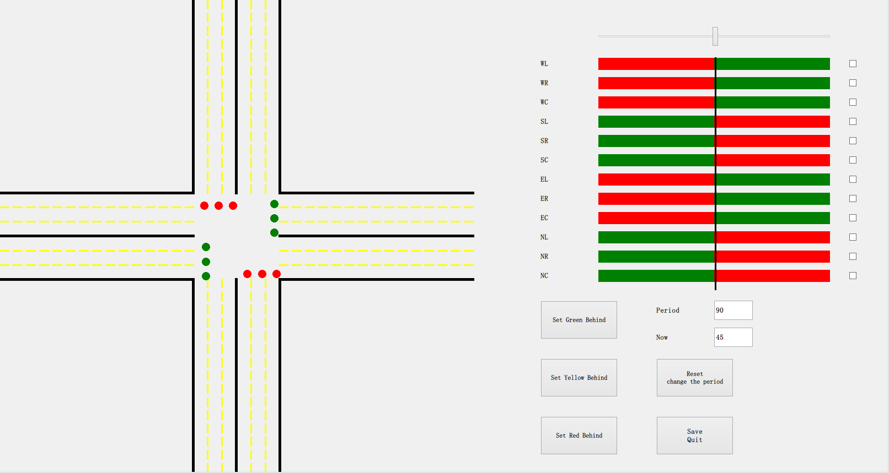

Figure 2 The signal preset interface of the intersection traffic control simulation system   
in the connected-vehicle environment

Before simulation, the traffic volume from each direction and the penetration rate (i.e. the ratio of vehicles that install the speed guidance equipment) can be preset. The simulation speed can be chosen from the interface: fast, medium, slow and very slow. In addition, both the running time and the number of vehicles through each direction can be monitored. Figure 3 shows that the traffic volume from each direction is 1080 veh/h, the penetration ratio is 0.3, the simulation speed is ‘medium’, and the simulation has run for 319.4 seconds.

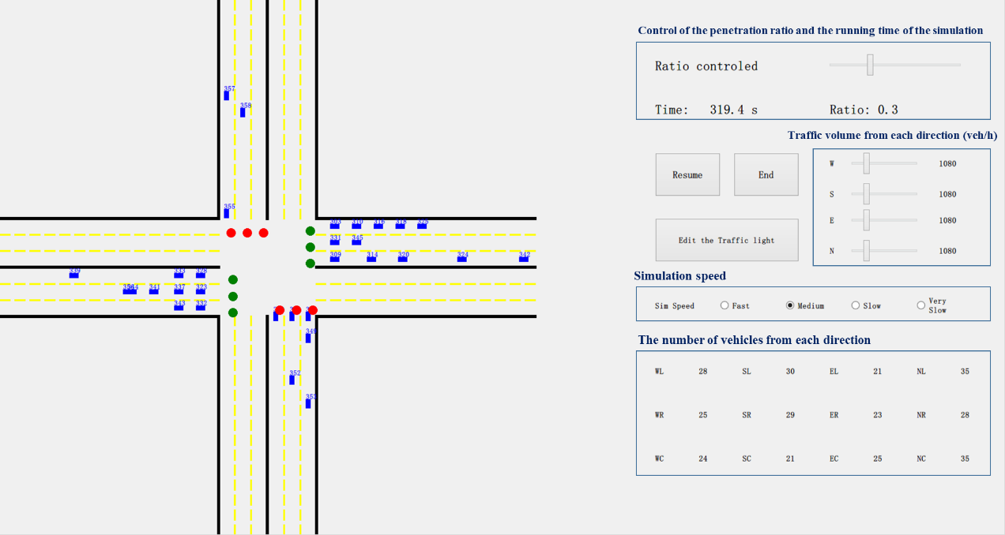

Figure 3 The operation interface of the intersection traffic control simulation system   
in the connected-vehicle environment

EXPERIMENTAL RESULTS

We conducted a simulation-based case study using the simulation system introduced above. The results obtained from the simulation experiments are presented in this section. Furthermore, we have a discussion on the differences between the two speed guidance strategies.

1. **The Effect of Speed Guidance Algorithm on Traffic Efficiency under Different Traffic Volumes**

We chose three common measures as indexes of traffic efficiency, i.e. average delay of vehicles, average number of stops, and average stop time. To test the effectiveness of the algorithm, the signal cycle is preset to be 90 s, with a green ratio of 50% (i.e. each direction has a green time for 45 s), and the traffic volume from each direction is preset to be the same, which ranges from 300 to 2700 veh/h (for 300 veh/h intervals) so that the traffic saturation states of low, medium and high can all be covered.

According to the data we measured at an intersection, when the light turns to green, the queue clearance speed is about 2.5 s/veh (i.e. 0.4 veh/s). According to this, the saturation traffic volume of three lanes is calculated as: 3600 s/h ÷ 2 ÷ 2.5 s/veh × 3 = 2160 veh/h.

It should be noted that when the traffic volume is higher than the saturation volume, vehicles would gradually accumulate in line. As a results, the collapse of the system will be inevitable. The run time of the simulation experiment is set to be 3600 s. The aim is to ensure enough time for the system to operate stably and to avoid the collapse of the system. Therefore, in the following experiment results, when the traffic flow is lower than 2160 veh/h, the test results will converge to a corresponding numerical test result, whereas when the traffic flow is higher than 2160 veh/h, the test results will be divergent. We only recorded the run results within 3600 s.

1. Analysis of average delay

As stated above, the purpose of speed guidance is to reduce the time to pass the stop-line. Therefore, the average delay of vehicles is chosen as the main index to measure the effectiveness of the algorithms. The delay of a vehicle is defined as the actual time it used to pass the stop-line minus the virtual time it needs, which is calculated as the distance divided by the initial velocity.

As shown in Table 2, in the case of no speed guidance, the average delay increases slowly with the increase in traffic volume when unsaturated; however, when over saturated (e.g. traffic volume is 2400 veh/h), the average delay increases sharply as most vehicles have to wait for at least one signal cycle before they can pass the stop-line (refer to Figure 4). In the case of single-vehicle speed guidance, when the traffic volume is lower than 2100 veh/h, the average delay is about 80% of that without speed guidance; when the traffic volume is larger than 2400 veh/h, the average delay is about 60% or even lower of that without speed guidance; when the traffic volume reaches 2700 veh/h, most vehicles also have to wait for at least one signal cycle. In the case of multi-vehicle cooperative speed guidance, the average delay increases steadily, with no oversaturation. When the traffic volume is lower than 2100 veh/h, the average delay is about 70% of that without speed guidance; when the traffic volume is large than 2400 veh/h, the average delay is only about 20% or even lower of that without speed guidance. Therefore, it can be concluded that speed guidance in the connected-vehicle environment can significantly reduce the average delay of vehicles. Besides, compared with the strategy of single-vehicle speed guidance, multi-vehicle cooperative speed guidance is more effective.

Table 2 The average delay of three speed guidance strategies under different traffic volumes

|  |  |  |  |  |  |  |  |  |  |  |
| --- | --- | --- | --- | --- | --- | --- | --- | --- | --- | --- |
| Traffic volume (veh/h) | | 300 | 600 | 900 | 1200 | 1500 | 1800 | 2100 | 2400 | 2700 |
| Average delay of vehicles (s) | Without speed guidance | 18.13 | 20.08 | 21.73 | 24.12 | 25.81 | 28.56 | 34.36 | 106.01 | 210.84 |
| single-vehicle speed guidance | 14.56 | 16.39 | 18.07 | 19.85 | 21.21 | 23.60 | 28.13 | 40.17 | 109.58 |
| multi-vehicle cooperative speed guidance | 12.60 | 14.55 | 16.05 | 17.38 | 18.78 | 20.23 | 21.87 | 23.48 | 25.18 |

Figure 4 Comparison of the average delay of three speed guidance strategies   
under different traffic volumes

1. Analysis of average number of stops

The number of stops can directly affect the average delay of vehicles. It can also reflect the traffic efficiency. Basing on the analysis results, we found that the variation pattern of average number of stops under different traffic volumes (as shown in Table 3 and Figure 5) is similar to the variation pattern of average delay. In the case of no speed guidance, the average number of stops rises with the increase in traffic volume, and remains smaller than 1 when the traffic volume is unsaturated; however, when traffic volume reaches 2400 veh/h, the average number of stops rises sharply and becomes larger than 1, therefore, there is saturation. In the case of single-vehicle speed guidance, when the traffic volume is lower than 2100 veh/h, the average number of stops is about 70% of that without speed guidance; when the traffic volume is larger than 2400 veh/h, the average number of stops is only about 40% or even lower of that without speed guidance. In the case of multi-vehicle cooperative speed guidance, the average number of stops is always around 0.2, and it is only about 30% or even lower of that without speed guidance.

Table 3 The average number of stops of three speed guidance strategies   
under different traffic volumes

|  |  |  |  |  |  |  |  |  |  |  |
| --- | --- | --- | --- | --- | --- | --- | --- | --- | --- | --- |
| Traffic volume (veh/h) | | 300 | 600 | 900 | 1200 | 1500 | 1800 | 2100 | 2400 | 2700 |
| Average number of stops | Without speed guidance | 0.54 | 0.55 | 0.56 | 0.58 | 0.57 | 0.58 | 0.63 | 1.49 | 3.00 |
| single-vehicle speed guidance | 0.35 | 0.36 | 0.37 | 0.38 | 0.39 | 0.39 | 0.44 | 0.55 | 1.39 |
| multi-vehicle cooperative speed guidance | 0.18 | 0.19 | 0.21 | 0.21 | 0.19 | 0.19 | 0.19 | 0.20 | 0.19 |

Figure 5 Comparison of the average number of delays of three speed guidance strategies   
under different traffic volumes

1. Analysis of average stop time

The average stop time of vehicles is also a common measure of traffic efficiency at intersections. As shown in Table 4 and Figure 6, through speed guidance, the average stop time of vehicles decreases. When the traffic volume is lower than the saturation volume, the optimization effects of single-vehicle speed guidance and multi-vehicle cooperative speed guidance are about 20% and 50% respectively. When the traffic volume is higher than the saturation volume (e.g. 2400 veh/h), the optimization effects of single-vehicle speed guidance and multi-vehicle cooperative speed guidance are about 50% and 90% respectively.

Table 4 The average stop time of three speed guidance strategies   
under different traffic volumes

|  |  |  |  |  |  |  |  |  |  |  |
| --- | --- | --- | --- | --- | --- | --- | --- | --- | --- | --- |
| Traffic volume (veh/h) | | 300 | 600 | 900 | 1200 | 1500 | 1800 | 2100 | 2400 | 2700 |
| Average stop time (s) | Without speed guidance | 10.45 | 11.17 | 11.69 | 12.09 | 12.35 | 13.10 | 15.66 | 54.61 | 122.35 |
| single-vehicle speed guidance | 8.21 | 8.63 | 9.12 | 9.75 | 10.17 | 11.02 | 13.14 | 20.49 | 71.22 |
| multi-vehicle cooperative speed guidance | 5.80 | 5.88 | 5.99 | 6.07 | 6.05 | 6.07 | 6.20 | 6.74 | 6.90 |

Figure 6 Comparison of the average stop time of three speed guidance strategies   
under different traffic volumes

1. **The Effect of Penetration Rate on Traffic Efficiency under Different Traffic Volumes**

To understand the value of using information from connected vehicles, simulation tests were conducted by varying the assumed penetration rate between 0% and 100% with 10% intervals. For these tests, the signal cycle was set to 90 seconds, with a green ratio of 50%, and the traffic volume from each direction being 2160 veh/h. Simulation tests were run to check the average delay of the two speed guidance strategies under different penetration rates, with the results shown in Table 5.

The average delay of vehicles resulting from different penetration rates are shown in Figure 7. For both the single-vehicle speed guidance and the multi-vehicle cooperative speed guidance algorithms, as the penetration rate increases, the average delay of vehicles significantly decreases. However, the marginal benefit obtained from more vehicles using this technology becomes relatively small after a penetration rate of 40% (for both speed guidance strategies). This implies that when the technology is in the early stage of development (i.e., when the penetration rate is low), even a few more equipped vehicles can have a significant effect on reducing the delays of all the vehicles at an intersection. At these low penetration rates, the information obtained from each vehicle is very valuable. However, at high penetration rates, the additional information becomes less and less valuable. Guler, Menendez and Meier [21] found similar effects of penetration rate.

Table 5 The average delay of two speed guidance strategies under different penetration rates

|  |  |  |  |  |  |  |  |  |  |  |  |  |
| --- | --- | --- | --- | --- | --- | --- | --- | --- | --- | --- | --- | --- |
| Penetration rate | | 0% | 10% | 20% | 30% | 40% | 50% | 60% | 70% | 80% | 90% | 100% |
| Average delay of vehicles (s) | single-vehicle speed guidance | 42.50 | 39.87 | 36.01 | 34.69 | 32.16 | 31.46 | 31.31 | 31.32 | 30.28 | 29.69 | 28.19 |
| multi-vehicle cooperative speed guidance | 42.64 | 39.83 | 34.94 | 31.40 | 26.39 | 25.87 | 24.72 | 24.39 | 23.83 | 23.08 | 22.60 |

Figure 7 The effect of penetration rates on average delay (a volume of 1080 veh/h per direction)

1. **Comparison of Two Speed Guidance Strategies**

Through the above comparison, we can conclude that speed guidance under the connected-vehicle environment can significantly improve the intersection efficiency, and that compared with single-vehicle speed guidance, multi-vehicle cooperative speed guidance is more effective.

Further analysis implies that the two speed guidance strategies both reduce the average delay of most vehicles, as Figure 8 shows. As the traffic volume grows, the multi-vehicle cooperative speed guidance can significantly move the overall distribution of vehicle delay to the left (i.e. significantly reduce the delay of most vehicles), thus significantly lowering the average delay of vehicles at the intersection.

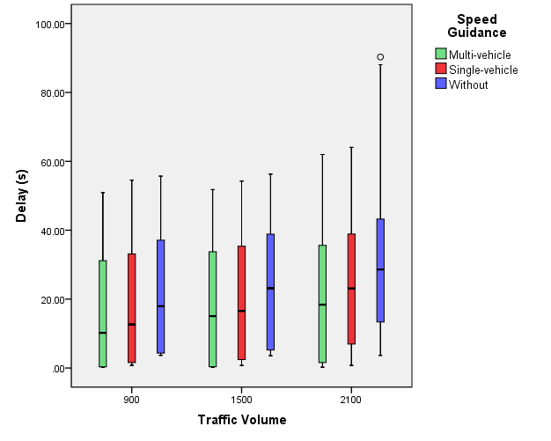

Figure 8 The boxplot of the average delay of three speed guidance strategies

The reason behind such difference mainly lies in that when single-vehicle speed guidance is applied, the states of other vehicles around are unknown, therefore the objective of speed guidance might not be realized. For example, if the single-vehicle speed guidance algorithm guides a certain vehicle to run at the speed of 60 km/h in order to arrive at the intersection before the green light turns to red. However, the car before it runs at a speed lower than 60 km/h, thus the speed-guided vehicle has to lower down in order to avoid collision. This might result in the speed-guided vehicle failing to arrive at the intersection before the green light turns to red, and having to stop and wait. As for the multi-vehicle cooperative speed guidance algorithm, it optimizes all vehicles’ time to pass the stop-line, thereby calculating each vehicle’s guided speed, improving both the green time efficiency and the traffic efficiency.

CONCLUSION

In this study, we have built an intersection traffic-control simulation platform in the connected vehicle environment, and proposed two speed guidance algorithms by optimizing the travel time of individual vehicle and multi vehicles respectively. The goal of optimization is to minimize the travel time, and common indicators such as average delay of vehicles, average number of stops, and average stop time are chosen as indexes of traffic efficiency in simulation experiments.

The simulation results show that compared with the case of no speed guidance, when the traffic flow is unsaturated (lower than 2160 veh/h), the single-vehicle speed guidance algorithm can decrease the average delay by 20%, the number of stops by 30%, and the average stop time by 20%; whereas the multi-vehicle speed guidance algorithm can decrease the average delay by 30%, the number of stops by 70%, and the average stop time by 50%. When the traffic flow is saturated (higher than 2160 veh/h), the speed guidance algorithms perform much more outstandingly. Compared with the case of no speed guidance, the single-vehicle speed guidance algorithm can decrease the average delay by 40%, the number of stops by 60%, and the average stop time by 50%; whereas the multi-vehicle speed guidance algorithm can decrease the average delay by 80%, the number of stops by 70%, and the average stop time by 90%. With the increase of penetration rate, the effect of speed guidance gradually enhances, with the most obvious gains obtained when the penetration rate increases from 10% to 40%. However, when the penetration rate is higher than 60%, further increase in the penetration rate has little benefits on the effect of speed guidance algorithms.

The experimental results indicate that speed guidance in the connected vehicle environment can significantly improve the traffic efficiency of intersections, and compared with the single-vehicle speed guidance strategy, the multi-vehicle speed guidance strategy is more effective.

In the future, we will introduce vehicle-to-vehicle communication into the simulation system, and realize cooperative driving. In addition, we will optimize the speed guidance algorithms accordingly for a better result.

ACKNOWLEDGEMENT

This work was supported in part by the National Natural Science Foundation of China under Grant 61673233 and 71671100.

REFERENCES

1. L. Li and F.Y. Wang, Cooperative Driving at Blind Crossings using Intervehicle Communication, IEEE Transaction on Vehicular Technology, Vol. 55, No.6, November 2006.
2. L. Li and D.Y. Yao, A Survey of Traffic Control With Vehicular Communications, IEEE Transaction on Intelligent Transportation Systems, Vol. 15, No.1, November 2014.
3. U.S. Department of Transportation. https://www.its.dot.gov/cv_basics/index.htm.
4. N. Mohammad and P. Hossein. The effect of VII market penetration on safety and efficiency of transportation networks. Proceedings of International Conference on Communications Workshops. Dresden: IEEE, 2009.
5. J. Yao, H.Y. Fan, Y. Han, L. Cui. Adaptive Control at Intersection in Urban Area Based on Probe Data. Journal of University of Shanghai for Science and Technology, 2014, 36(3): 239-244.
6. A. H. Booz. Vehicle infrastructure integration (VII) proof-of-concept (POC) test—an overview. 2008 ITS VA Annual Conference. Charlottes Ville, 2008.
7. M. Nekoui. Development of a VII-enabled prototype intersection collision warning system. International Journal of Internet Protocol Technology, 2009(4):173-181.
8. K. J. Malakorn and B. B. Park. Assessment of mobility, energy, and environment impacts of intellidrive-based cooperative adaptive cruise control and intelligent traffic signal control. Proceedings of the 2010 IEEE International Symposium on Sustainable Systems and Technology, Hilton crystal city: IEEE Xplore, 2010(1):1-6.
9. G. Abu-Lebdeh. Exploring the potential benefits of intellidrive-enabled dynamic speed control in signalized networks. TRB 2010 Annual Meeting CD-ROM.
10. Y. Yang, S. Chen and J. Sun. Modeling and evaluation of speed guidance strategy in VII system. 3th International IEEE Annual Conference on Intelligent Transportation Systems, Portugal: IEEE Xplore, 2010:1045-1050.
11. S. Chen, J. Sun and J. Yao. Development and simulation application of a dynamic speed dynamic signal strategy for arterial traffic management. 4th International IEEE Annual Conference on Intelligent Transportation Systems, Washington, D. C., IEEE Xplore, 2011:1349-1354.
12. Q. He. Robust-intelligent traffic signal control within a vehicle-to-infrastructure and vehicle-to-vehicle communication environment. Tucson: The University of Arizona, 2010.
13. J. Lee and B. Park. Development and evaluation of a cooperative vehicle intersection control algorithm under the connected vehicles environment, IEEE Transactions on Intelligent Transportation Systems, 13(1): 8190, 2012.
14. R.T. Jackline and A.M. Andreas. Automated and Cooperative Vehicle Merging at Highway On-Ramps, IEEE Transactions on Intelligent Transportation Systems, 2016.
15. J.G. Taylor. Hierarchy-of-Models Approach for Aggregation-Force Attrition. Proceedings of the Winter Simulation Conference, 2000: 924-929.
16. X. Chen and D. Yao. An empirically comparative analysis of 802.11 n and 802.11 p performances in CVIS, ITS Telecommunications (ITST), 2012 12th International Conference on. IEEE, 2012: 848-851.
17. X. Chen, H. Li, C. Yang, et al. An Empirical Analysis of V2I Communication in Vehicular Ad-Hoc Network Based on IEEE 802.11n, 19th ITS World Congress. 2012.
18. X. Chen, D. Yao, Y. Zhang, et al. Design and Implementation of Cooperative Vehicle and Infrastructure System Based on IEEE 802.11n. Transportation Research Record: Journal of the Transportation Research Board, 2011, 2243(1): 158-166.
19. W. Leutzbach and R.Wiedemann. Development and applications of traffic simulation models at the Karlsruhe Institut für Verkehrswesen. Traffic engineering and control, vol. 27, no. 5, pp. 270-278, 1986.
20. Regulation on the Implementation of the Road Traffic Safety Law of the People’s Republic of China. 2004.
21. S. I. Guler, M. Menendez and L. Meier. Using connected vehicle technology to improve the efficiency of intersections. Transportation Research Part C: Emerging Technologies, 2014, 46: 121-131.